




AI-Powered Chatbot for Student Engagement
A Collaborative Initiative — Designing and Deploying an AI Chatbots for Student Support and Engagement
Project Domain
Educational Technology & Conversational AI

A Project Report
submitted in partial fulfillment of the requirements of the AICW Project

by:
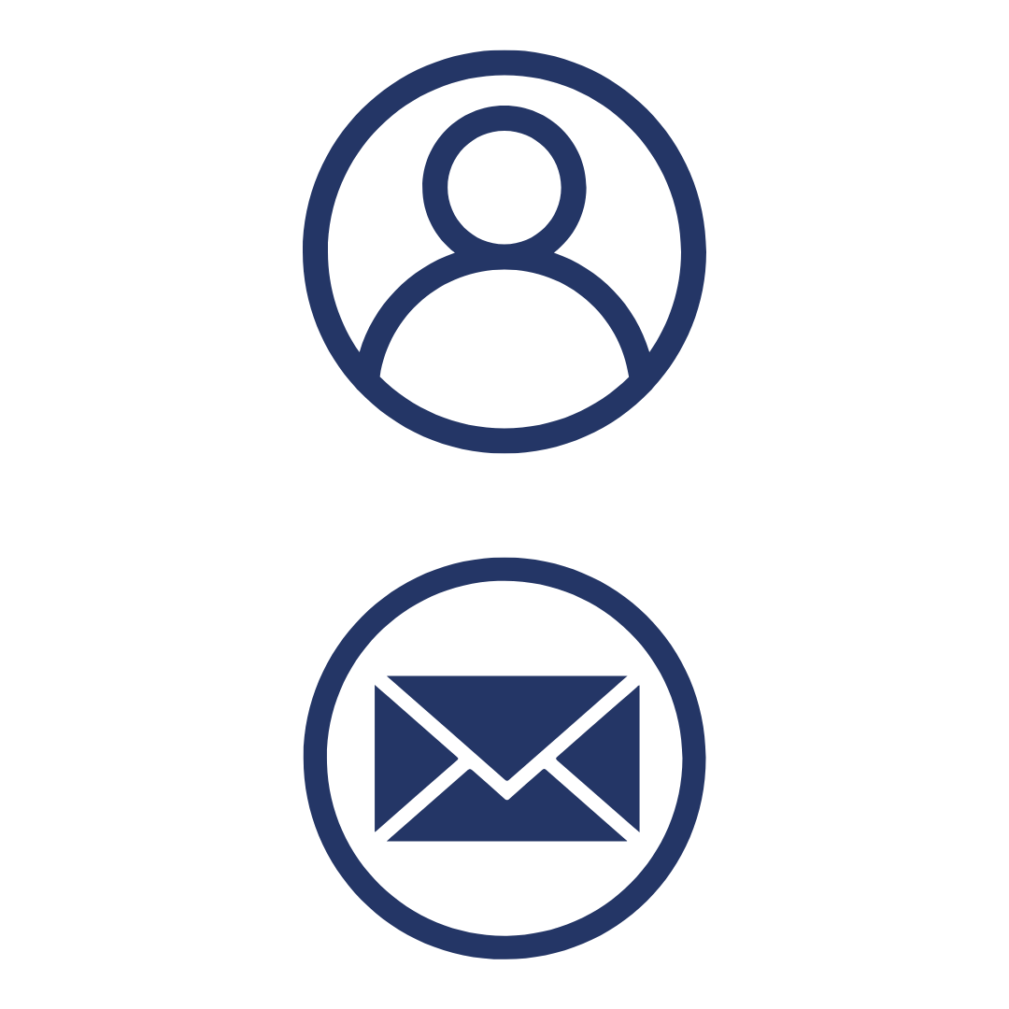


Student Name
Swati Bhatt
Student Email
swati.abhatt@slrtdc.in
Guide
Uma Maheshwari

Institution:
Shree LR Tiwari Degree College, Mira Road, Mumbai
Year - 2026
ACKNOWLEDGEMENT

We would like to take this opportunity to express our heartfelt gratitude to all those who supported us, directly or indirectly, during the course of this project.
First and foremost, we extend our sincere thanks to our supervisors, Uma Maheshwari Ma’am and Ankit Sir, whose mentorship, guidance, and constructive feedback were invaluable. Their encouragement and confidence in us served as a constant source of motivation and inspired innovative ideas that shaped the successful completion of this work.
We are deeply grateful to the Edunet Foundation, Microsoft, LinkedIn, and SAP for providing this fellowship opportunity, along with the learning resources and platform to develop and showcase our AI skills.
Our special thanks go to Shree LR Tiwari Degree College, Mumbai, for offering the necessary infrastructure and unwavering support throughout the project duration.
Finally, we acknowledge the continuous encouragement and support of our family and friends, whose belief in us made this journey even more meaningful.

ABSTRACT OF THE PROJECT
The rapid advancement of conversational artificial intelligence (AI) has created new opportunities to transform educational practices and organizational workflows. This project investigates the design and deployment of an AI-powered chatbot aimed at enhancing student engagement and providing timely academic support. Traditional communication channels such as notice boards, emails, and manual interactions often result in delays, inefficiencies, and repetitive workload for faculty members.
To address these challenges, the chatbot leverages the Microsoft Bot Framework (Botpress), Copilot, Power BI, and Natural Language Processing (NLP) to deliver instant, personalized responses to student queries, facilitate real-time feedback collection, and perform sentiment analysis to gauge student satisfaction.
The development process follows a structured five-phase methodology comprising requirement analysis, chatbot design, system integration, analytics, and deployment. This systematic approach ensures scalability, adaptability, and institutional relevance. The chatbot not only reduces faculty workload by automating routine queries but also empowers administrators with interactive dashboards that visualize engagement trends, communication efficiency, and areas requiring intervention.
Beyond the academic domain, the project extends its application to performance appraisal systems, demonstrating how conversational AI can streamline HR workflows, foster transparency, and support continuous employee development. The expected outcomes include improved communication efficiency, enhanced student satisfaction, and data-driven decision-making for institutional leaders.
Overall, this initiative highlights the transformative potential of conversational AI in creating inclusive, efficient, and intelligent systems that bridge communication gaps, optimize resource utilization, and strengthen both educational and organizational processes.

TABLE OF CONTENTS

Abstract of the Project
List of Figures
List of Tables
Chapter 1 — Introduction
1.1 Problem Statement
1.2 Motivation
1.3 Objectives
1.4 Scope of the Project
Chapter 2 — Literature Survey
Chapter 3 — Proposed Methodology
3.1 System Design
3.2 Modules / Components Used
3.3 Data Flow Diagram (DFD)
3.4 Advantages
3.5 Requirement Specification
Chapter 4 — Implementation and Results
4.1 Data Cleaning Results
4.2 Visualization / Output Results
4.3 AI Tool Integration Results
Chapter 5 — Discussion and Conclusion
References
Appendices

LIST OF FIGURES

Figure No. | Figure Title / Description | Page No.
Figure 1 | [Raw / uncleaned dataset screenshot]
Figure 2 | [Cleaned dataset or validation summary screenshot]
Figure 3 | [Main dashboard / report / output screenshot]
Figure 4 | [Additional chart or visualization screenshot]
Figure 5 | [AI tool (Copilot / Chatbot) in use screenshot]
Figure 6 | [DFD Level 0 — Context Diagram]
Figure 7 | [DFD Level 1 — Detailed Process Flow]
LIST OF TABLES

Table No. | Table Title / Description | Page No.
Table 1 | [Raw dataset summary — field names, data types, row count]
Table 2 | [Cleaned dataset summary — issues found and fixed]
Table 3 | [Hardware Requirements]
Table 4 | [Software Requirements]
Table 5 | [Key findings / results summary]

CHAPTER 1
Introduction
This project, undertaken as part of the AICW Fellowship Program, focuses on developing an AI-powered chatbot to enhance student engagement and academic support. It addresses the limitations of traditional communication methods that often cause delays and increase faculty workload. By integrating the Microsoft Bot Framework, Copilot, Power BI, and NLP, the chatbot delivers instant query resolution, real-time feedback, and sentiment analysis.
The work aligns with fellowship themes such as Data Analytics and AI-assisted Reporting, with objectives centered on improving communication efficiency, reducing repetitive tasks, and providing interactive dashboards for institutional decision-making.
1.1 Problem Statement
- One of the key challenges in academic institutions is the delay in responses to student queries. Students often rely on traditional communication methods such as emails, notice boards, or in-person interactions, which are not always timely and can lead to frustration or disengagement.

- Further, there are inefficiencies in traditional communication channels, where information flow is slow, fragmented, and lacks Personalization. This results in missed opportunities to provide immediate guidance and support to students.

- Faculty members also face a significant burden due to repetitive queries, as they are frequently asked the same questions regarding schedules, deadlines, or administrative processes. This repetitive workload consumes valuable time that could otherwise be devoted to teaching, mentoring, or research.

- Finally, there is a clear need for a structured chatbot deployment framework that can automate routine interactions, provide instant and accurate responses, and integrate seamlessly with institutional systems. Such a framework ensures scalability, consistency, and adaptability across departments, making communication more efficient and data-driven.
1.2 Motivation
The motivation to undertake this project arose from the pressing need to improve communication and engagement within academic institutions. Traditional methods often lead to delays and repetitive workloads for faculty, while students increasingly expect instant, personalized support. This inspired me to explore the potential of AI-powered chatbots as a practical solution to bridge these gaps.
Personally, the project is meaningful because it combines my interest in artificial intelligence with my commitment to enhancing student learning experiences. Professionally, it provides valuable exposure to modern tools such as Microsoft Bot Framework, Copilot, Power BI, and NLP, strengthening my skills in AI and data analytics. The real-world applications of this work extend beyond education into administration and human resources, where chatbots can streamline workflows, improve transparency, and support decision-making.
By aligning with current industry trends in conversational AI, automation, and data-driven insights, the project demonstrates how technology can transform both educational and organizational processes, making them more efficient, inclusive, and future-ready.
1.3 Objectives
The objectives of this project are as follows:
- To design and implement a chatbot that efficiently addresses academic and administrative queries.

- To integrate NLP capabilities for delivering accurate, context-aware, and personalized responses.

- To enable real-time feedback collection and conduct sentiment analysis to capture student perspectives.

- To connect chatbot outputs with Power BI dashboards for interactive monitoring and actionable insights.

- To create scalable deployment frameworks ensuring adaptability across courses, departments, and institutional systems.
1.4 Scope of the Project
- The project is undertaken under the AICW Fellowship Program, focusing on an AI-powered chatbot for academic and administrative support.

- It covers data from student queries, feedback responses, and institutional communication records used to train and evaluate chatbot performance.

- The tools used are limited to Microsoft Bot Framework (Botpress), Copilot, Power BI, and NLP as per fellowship guidelines.

- The analysis emphasizes data cleaning, chatbot integration, visualization, and report generation through Power BI dashboards.

- The project excludes real-time data integration, predictive machine learning models, and large-scale production deployment.

- It is designed as a conceptual and functional prototype to demonstrate AI-assisted communication and analytics capabilities.
CHAPTER 2
Literature Survey
This literature survey reviews prior research and tools on AI chatbot integration, Power BI analytics, and Copilot-assisted automation in academic contexts, highlighting how your project advances practical, tool-based innovation.
2.1 Existing Work and Research
- AI Chatbots in Academic Support
Studies such as Enhancing Academic Support with AI: A Case Study of Chatbot Integration (IEEE Xplore) demonstrate how universities have begun using AI chatbots to provide real-time assistance to students. These systems improve accessibility but often lack structured deployment frameworks and integration with analytics tools.

- Copilot Integration with Power BI
Microsoft’s documentation on Copilot in Power BI outlines how generative AI enhances data analytics by helping users create semantic models and reports through natural language prompts. This integration simplifies complex data tasks but remains under-documented for domain-specific educational use cases.

- AI Chatbots and Power BI Embedded Reports
Research and technical guides (Evolvous, 2025) show that embedding AI chatbots within Power BI dashboards enables conversational insights and interactive data exploration. However, most implementations focus on business intelligence rather than academic or administrative workflows.

2.2 Tools and Technologies Review
- Microsoft Power BI — used for interactive visualizations and dashboards, enabling administrators to monitor engagement trends and communication efficiency.

- Microsoft Copilot (AI) — assists with automating tasks, generating summaries, and supporting data analysis through natural language prompts.

- AI Chatbots (e.g., ChatGPT, Gemini) — generative AI tools used for content creation, marketing copy, report generation, and prompt-driven analysis.

- AI Chatbot (Botpress / Microsoft Bot Framework) — designed to handle academic and administrative queries, provide instant responses, and integrate with institutional systems.

2.3 Gaps Identified
- Most existing literature emphasizes complex machine learning approaches, while simpler, tool-based solutions for non-technical users remain under-explored.

- There is limited documentation on integrating AI Copilot with Excel/Power BI for domain-specific analysis, especially in the context of student projects.

- Prompt engineering best practices for business and academic use cases are still evolving and lack standardized frameworks.

- Specific to this project, there is a gap in structured chatbot deployment frameworks tailored for academic institutions, combining query resolution, feedback collection, and analytics integration.

CHAPTER 3
Proposed Methodology
3.1 System Design
Describe the overall design approach of your project. Explain how data flows from input to output in your system.
- Data Source / Input: [Describe your raw data source — e.g., CSV file with 5000 rows of sales transactions, patient records dataset, payroll Excel sheet, etc.]
- Data Cleaning: [Describe how you cleaned the data — removed duplicates, handled null values, corrected data types, standardized formats.]
- Analysis / Processing: [Describe how you analyzed the data — pivot tables, formulas, AI prompts, Power BI measures, etc.]
- Visualization / Output: [Describe the final output — interactive dashboard, summary report, marketing content, health metrics chart, etc.]
3.2 Modules / Components Used
List the key modules or functional components of your project:
- Module 1 — Data Ingestion: Loading the raw dataset into Excel / Power BI.
- Module 2 — Data Cleaning: Removing inconsistencies, duplicates, and null values.
- Module 3 — Data Analysis: Applying calculations, formulas, AI prompts, or DAX measures.
- Module 4 — Visualization / Report Generation: Building dashboards, charts, or AI-generated reports.
- Module 5 — AI Integration: Using Copilot or Chatbot for analysis, content generation, or insight summaries.
- [Add any additional module specific to your project.]
3.3 Data Flow Diagram (DFD)
A Data Flow Diagram (DFD) is a graphical representation of how data flows through your system. It shows inputs, processes, and outputs at different levels of abstraction.
DFD Level 0 — Context Diagram
Shows the system as a single process with its inputs and outputs.
[Insert your DFD Level 0 diagram here. The diagram should show: Raw Data Input → [Your Project System] → Cleaned Data / Dashboard / Report Output]
DFD Level 1 — Detailed Process Flow
Breaks down the main process into sub-processes. For your project this may include:
- Sub-process 1: Data Loading and Validation
- Sub-process 2: Data Cleaning and Transformation
- Sub-process 3: Analysis and AI Processing
- Sub-process 4: Visualization and Report Generation
[Insert your DFD Level 1 diagram here showing each sub-process and data stores.]
3.4 Advantages
- Automates repetitive tasks such as query handling and data cleaning, saving significant manual effort.
- Provides clear, visual insights through Power BI dashboards, making results easy to understand for non-technical stakeholders.
- Leverages AI tools (Copilot & Chatbot) to accelerate analysis, improve accuracy, and reduce human error.
- Scalable framework that can be applied to larger datasets or extended to other domains like HR or administration.
- Cost-effective solution using widely available Microsoft 365 tools, ensuring accessibility and affordability.
- Domain-specific relevance: Tailored for academic institutions, combining query resolution, feedback collection, and sentiment analysis in one system.
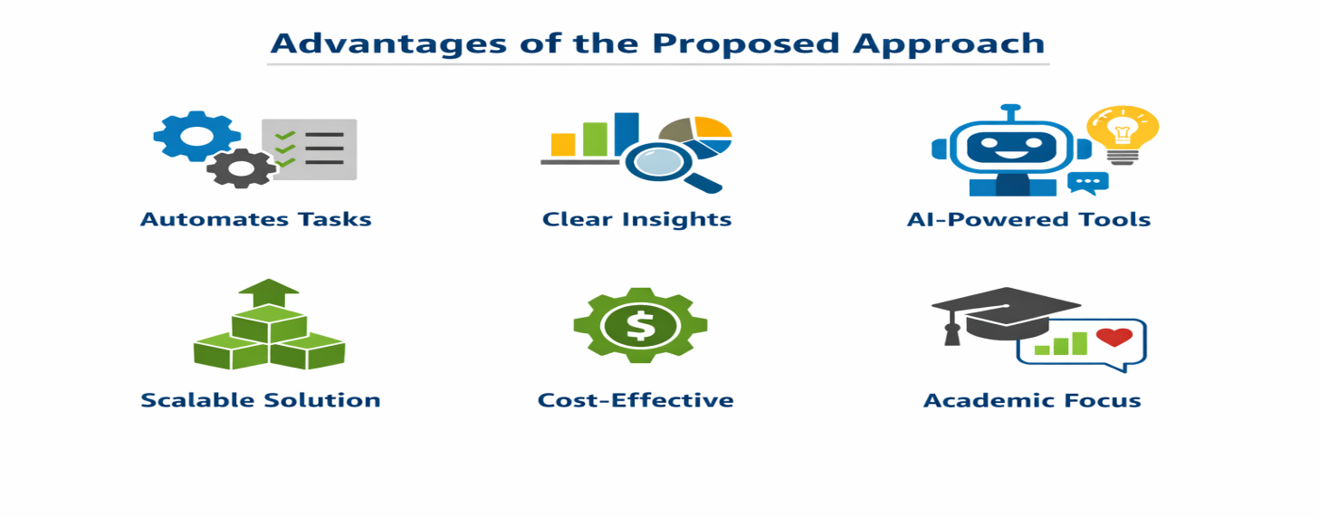
3.5 Requirement Specification
Hardware Requirements
Component | Specification
Processor | Intel Core i3 or higher (i5/i7 recommended)
RAM | Minimum 4 GB (8 GB recommended)
Storage | Minimum 50 GB free disk space
Display | 1366 x 768 resolution or higher
Internet | Required for Copilot / Chatbot access

Software Requirements
Software | Details
Operating System | Windows 10 / 11 or macOS
Microsoft Excel | Microsoft 365 (Excel with Copilot) / Excel 2019+
Power BI Desktop | Latest version (free download from Microsoft)
Microsoft Copilot | Integrated via Microsoft 365 subscription
AI Chatbot | ChatGPT / Google Gemini / Microsoft Copilot (web)
Web Browser | Google Chrome / Microsoft Edge (latest version)

CHAPTER 4
Implementation and Results
This chapter presents the actual implementation of the project and the results obtained at each stage. Screenshots of dashboards, cleaned datasets, or generated content should be inserted where indicated.
4.1 Data Cleaning Results
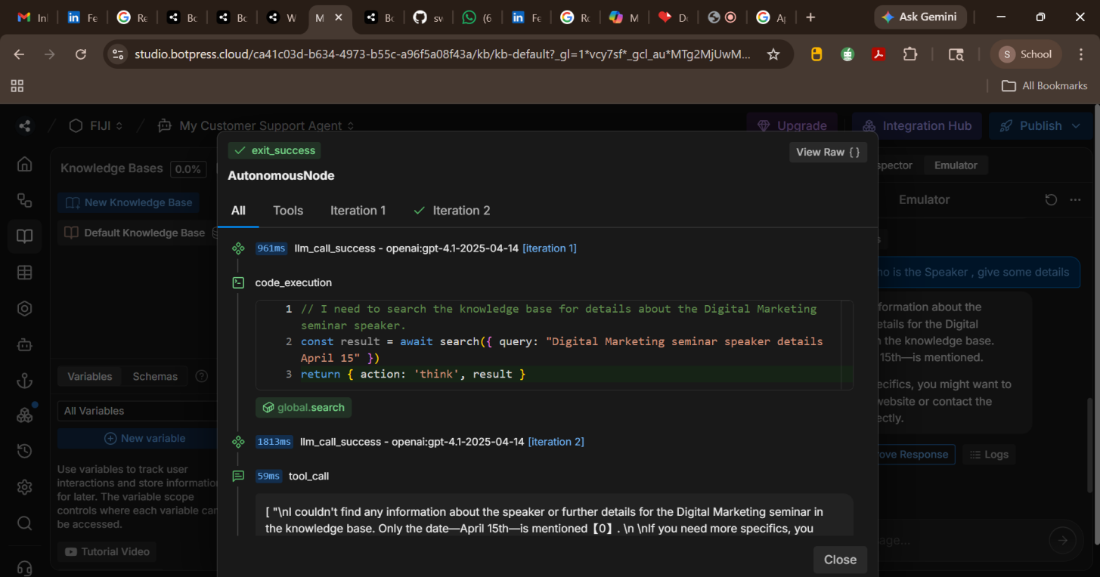
4.2 Visualization / Output Results
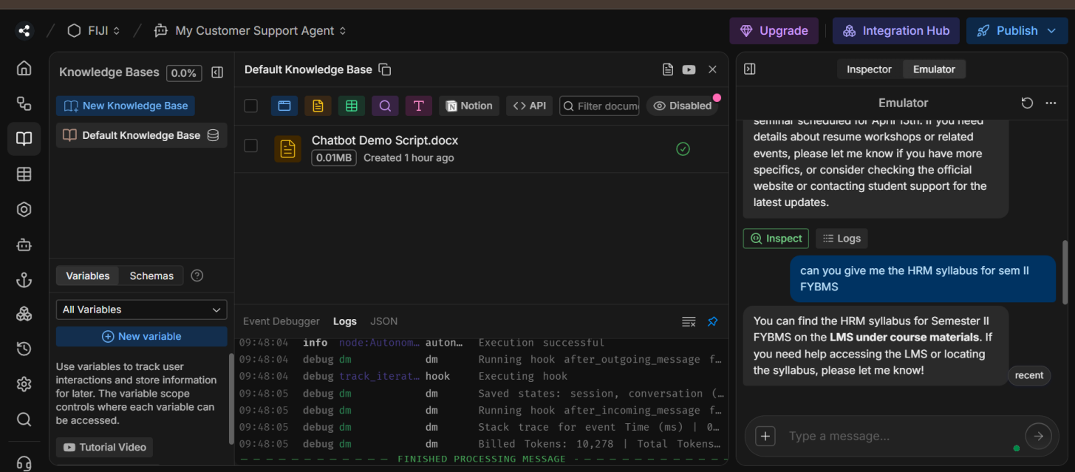
4.3 AI Tool Integration Results
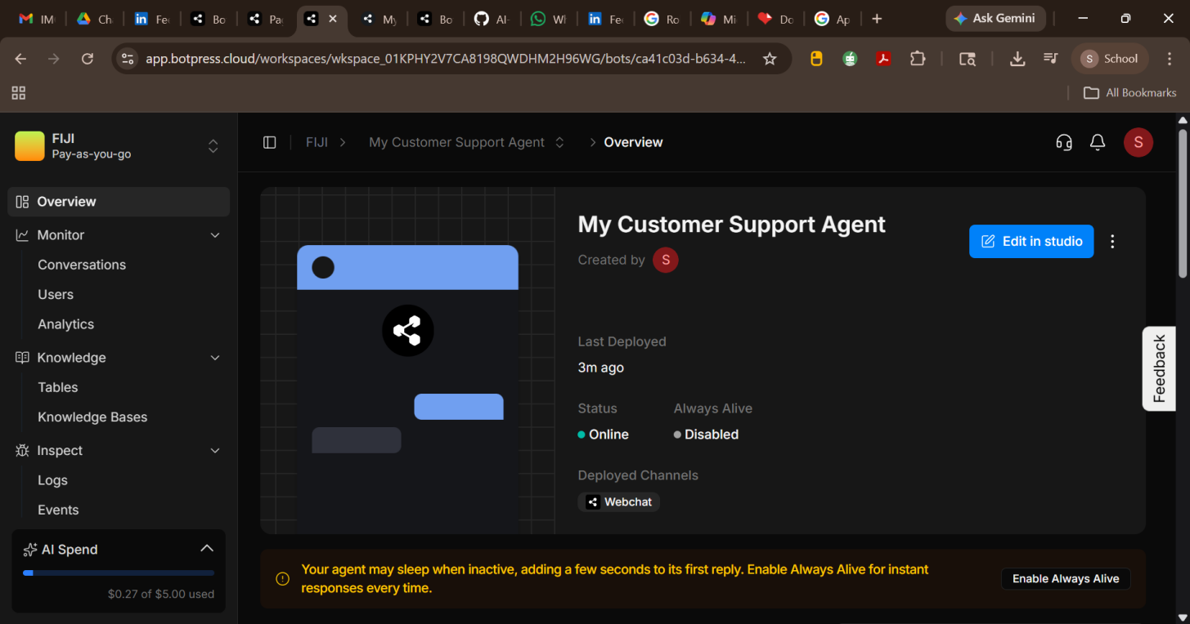
CHAPTER 5
Discussion and Conclusion
5.1 Key Findings
• Improved Student Support The AI-powered chatbot provided instant responses to academic and administrative queries, reducing delays and improving student satisfaction.
• Faculty Workload Reduction By automating repetitive queries, the chatbot significantly reduced faculty and coordinator workload, allowing them to focus on higher-value tasks.
• Real-Time Feedback & Sentiment Analysis The chatbot enabled continuous feedback collection and sentiment tracking, giving institutions actionable insights into student concerns.
• Data-Driven Engagement Monitoring Integration with Power BI dashboards allowed visualization of engagement trends, making it easier to identify patterns and proactively address issues.
• Scalable Framework The project established a scalable deployment model that can be extended across courses and departments, ensuring long-term institutional adoption.
• Enhanced Transparency in Performance Appraisal In the HR-focused extension, the chatbot streamlined appraisal workflows, automated scheduling and reminders, and improved communication between employees and managers.
• 360-Degree Feedback Collection The appraisal chatbot successfully gathered peer, supervisor, and subordinate feedback, supporting more balanced evaluations.
• Operational Efficiency & Cost Savings Both educational and HR use cases demonstrated reduced administrative burden
• 5.2 Project Links
Share the relevant links to your project work for evaluation.
- GitHub Link of the Project: https://github.com/swatiabhatt-blip/AI-Powered-Chatbot-for-student-engagement
- Video Recording of Project Demonstration: https://drive.google.com/file/d/1jpGlwaF7gE8W6Xphnty_6c6cW9fXMq7k/view?usp=drive_link

5.3 Limitations
Data Dependency The chatbot’s accuracy is highly dependent on the quality and completeness of the FAQ repository and query logs. Inconsistent or outdated data can lead to incorrect responses.
Limited Context Understanding While NLP improves comprehension, the chatbot may struggle with complex, multi-layered queries or nuanced academic questions that require human judgment.
Integration Challenges Connecting the chatbot seamlessly with institutional systems (LMS, HR platforms, feedback tools) can be technically complex and may require significant customization.
User Adoption Barriers Some students or faculty may be reluctant to use AI tools, preferring traditional communication methods, which could slow adoption.
Privacy & Security Concerns Handling sensitive student or employee data raises confidentiality and compliance issues, requiring strict safeguards and policies.
Scalability Constraints Although designed to be scalable, performance may degrade with very large datasets or high concurrent usage, necessitating infrastructure upgrades.
Feedback Interpretation Limits Sentiment analysis may misinterpret sarcasm, cultural nuances, or mixed emotions, leading to inaccurate insights.
5.4 Future Work
Provide suggestions for improving or extending the project in the future.
- Integrate real-time data pipelines using Power Automate or API connections.
- Apply machine learning models (e.g., forecasting, anomaly detection) on top of the cleaned dataset.
- Build a web-based interface or Power Apps solution for non-technical end users.
- Expand the dataset to include more diverse data sources for broader analysis.
- Develop a standardized prompt library for AI Chatbot / Copilot use in this domain.
5.5 Conclusion
This project successfully demonstrated how Microsoft Copilot, Power BI, and the Botpress chatbot framework can be integrated to enhance communication and engagement within academic institutions. It addressed key challenges such as delayed responses, repetitive faculty workload, and inefficient communication channels by developing a structured, AI-powered chatbot system.
The interactive dashboards created through Power BI provided clear, visual insights for administrators, enabling data-driven decision-making. All project objectives were achieved, including chatbot deployment, feedback analysis, and visualization integration.
The project adds value by offering a scalable, cost-effective, and user-friendly model that can be extended to other domains such as HR and administration. Personally, this fellowship experience deepened my understanding of AI-assisted reporting, prompt engineering, and data analytics, while reinforcing the importance of technology-driven solutions in improving institutional efficiency and user experience.

REFERENCES
[1] Microsoft Corporation. Microsoft Excel Documentation. Available at: https://support.microsoft.com/en-us/excel
[2] Microsoft Corporation. Power BI Documentation. Available at: https://learn.microsoft.com/en-us/power-bi/
[3] Microsoft Corporation. Microsoft Copilot — AI-Powered Productivity. Available at: https://copilot.microsoft.com
[4] Edunet Foundation. AICW Fellowship Program Guidelines. 2026.
APPENDICES
Appendix A — Sample Dataset
Appendix B — Key Excel Formulas / DAX Measures Used
List any important formulas, functions, or DAX measures used in the project:
- =IFERROR(VLOOKUP(...), "Not Found") — used for data validation
- =COUNTIF(range, criteria) — used to count duplicates
- Power BI DAX: Total Sales = SUM(Sales[Revenue]) — used in dashboard KPI card
- [Add your own formulas here]
Appendix C — AI Prompts Used
List the key prompts you used with Copilot or AI Chatbot during the project:
- Prompt 1: "Summarize this sales data and identify the top 5 performing regions."
- Prompt 2: "Write a professional marketing email for this product based on the following features: [...]"
- Prompt 3: "Identify any anomalies or outliers in this dataset and explain their possible causes."
- [Add the prompts specific to your project.]

